City SafeZone Final Report

Prepared by: Andrew Carreiro, Yue Lian, Colton Sparvero

# Abstract

This report was designed to give an in-depth look of our capstone project named City SafeZone. The website was made to protect people from dangers in large U.S. cities. Crime in major cities has increased over time. People need to access to a resource that can inform them about where the most crimes are committed within the city. Our website is useful in preventing regular people from becoming victims of a crime. Our website can provide valuable knowledge to anybody, including people looking to travel to the city for a daytrip or for people who already live in the city. Development of our application combined HTML, Javascript, and CSS to create a working web page. We also embedded a Google Maps API to provide the user with a user-friendly resource to visualize where high rates of crime occur. The major constraints we experienced while developing our web page include time, lack of money, and experience coding. City Safezone has so much potential for future development and become an even more effective resource for people.

# Table of Contents

**Abstract**2

**Table of Contents**3

**INTRODUCTION**5

Problem Statement 5

Motivation 5

Objective 5

End-User Needs 5

**LITERATURE SURVEY**6

Literature Review 6

Assessment of Available Solutions and Techniques 7

Pros and Cons 8

**REQUIREMENT SPECIFICATIONS**9

Market Requirement Analysis 9

Design Requirement Analysis 9

Constraints 9

Assumptions 10

Outcome Criteria 10

Risks 10

**SYSTEM DEVELOPMENT**11

Concept Generation 11

System Planning 11

Principle Operation 13

Design Process 14

System Design 16

Frontend 16

Backend 17

API 17

Testing 18

Logical Testing 18

API Testing 19

Cross Browser Compatibility 20

**CONCLUSION**21

Changes in development 21

Challenges 21

Lesson Learned 22

**FUTURE WORK**23

Heatmap 23

Backend Data 24

Mobile App Development 24

References 25

# 

# 

# 

# 

# 

# 

# 

# **INTRODUCTION**

## Problem Statement

Over the past two years, the rate of crime, and unfortunately violent crime as well, has skyrocketed. While conversations turn to what caused this national crime bubble to burst, no one is talking about what everyday people can do to avoid these potentially fatal encounters with criminals. To solve this issue, we decided to create a map-based application to provide crime data to everyone easily.

## Motivation

Our motivation was to provide users with a peace of mind while they travel or move to a new city. Without knowing the neighborhoods and streets like a local, it’s hard to know what areas are safe, especially at night. We wanted to help people stop guessing and feel confident that they were safe while out and about.

## Objective

Our objective was to create an application that displays crime data as easily identifiable data points so that users can see what crimes happen in a city, how many and where. To do this the application was going to need a Maps API as a backbone for our application to display the data on.

## End-User Needs

The End-user Needs include a legible, maneuverable Map displayed as well as easily recognizable and visible data points to indicate the location where a crime takes place. The user also needs to know the address of that location, the type of crime, when it happened and if arrests were made.

# **LITERATURE SURVEY**

## Literature Review

Whenever people travel, they typically show concern for their own personal safety. During modern times, it is more important than ever to travel safely in major cities. In 2021, twelve cities in the U.S. have already broken annual homicide records before the end of the year (Hutchinson, 2021). Chicago, the third-largest city in the U.S., leads the country in homicides with 739 (Hutchinson, 2021). While murder rates in major cities are growing, people still want to drive into the cities to experience the melting pot of culture in these places. These major cities are home to the best restaurants, arts, music venues, and sporting events in the country. No one should ever have to fear for their life when heading into the city, however, increasing homicides in major cities causes visitors to turn away.

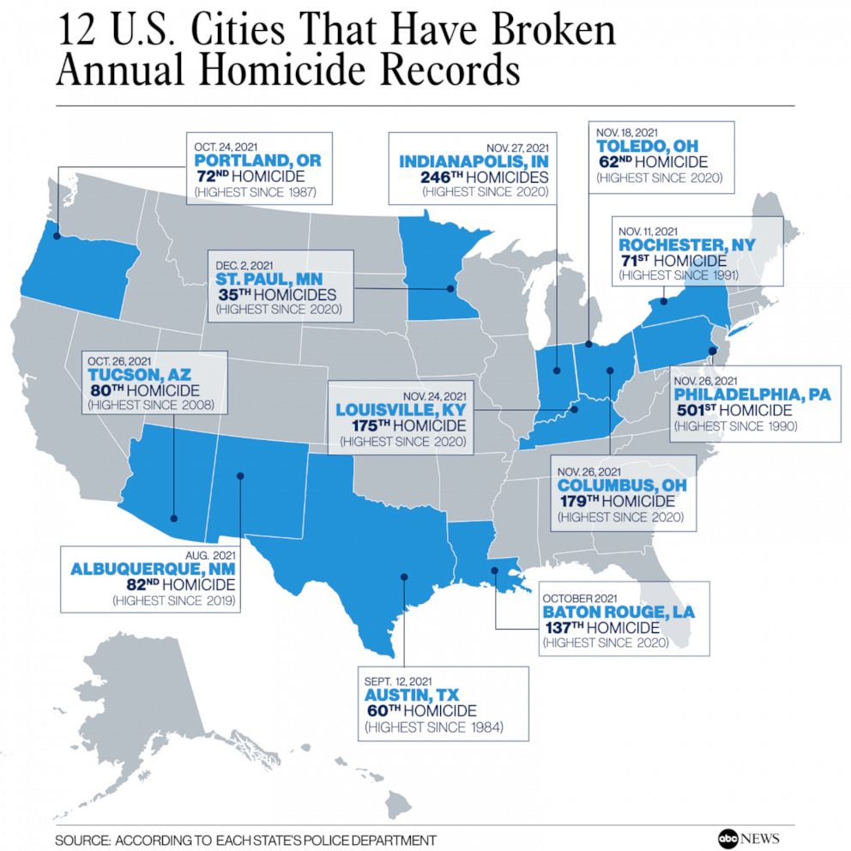

*Figure 1.1 - 12 U.S. CITIES THAT HAVE BROKEN ANNUAL HOMICIDE RECORDS. (2021, December 8). [Map]. ABC News. https://abcnews.go.com/US/12-major-us-cities-top-annual-homicide-records/story?id=81466453*

Not every part of major cities are dangerous. There are certain areas where violent crimes occur more often than others. For example, Kensington, Philadelphia is the poorest area in all of America’s large cities (Community Health, 2019). In 2019, Kensington’s violent crime rate was “roughly 30% higher (328 violent crimes per 10,000 residents) than in Philadelphia overall (242 violent crimes per 10,000 people)” (Community Health, 2019). However, Kensington may have some popular attractions that could interest people from outside of the city which can encourage travel to the neighborhood. It is in a visitor’s best interest to become aware of the safest and most dangerous spots in a city. When certain sections of a city become dangerous, it causes some visitors to turn away from the entire city in general, hurting the local economy.

People who have landed a new job in a major city also have to become knowledgeable about crime in the nearby area. Depending on how far away the new employee comes from, they may not be familiar with dangerous spots within a city. Crime in the area must be taken into consideration when buying or renting a new home in the city to allow for a safe commute. Newcomers to the city might also want to make sure they can leave their families safe without too much worrying.

Our solution to the problems is an application that will display a heat map of the dangerous areas in major cities based on recent crime data. The user will have the ability to input their destination and the application will provide a visualization of dangerous places in the area. The application is designed to make users feel safer when making traveling decisions into the city.

## Assessment of Available Solutions and Techniques

Currently there exists multiple approaches to our problem. The first, and most abundant, approach to solving our problem are Neighborhood watch apps. These applications, such as Naber and Saferwatch, allow users to report crimes they witness, and a notification gets sent to users as well as displaying a location pin on a satellite map. These apps feature functionality to enable users to report a crime as well as some basic information.

The next approach is a similar application to our project’s. In our application, we want to display a heat map that shows the different crime rate levels in that area; however, a different approach is that the map will display the recent crimes that happened in the location by the community members reporting the incidents. The map will identify the type of crime activity by using basic emoticons and pin it in the address that it occurred.

Lastly, an alternative citizens could use to be alerted about crimes in the area is to turn on local media. Media provides citizens news about local crimes on television and radio. If someone plans to visit a major city, they could watch the local news to see if any major crimes happened before they visit. They could also listen about local crimes on their car ride into the city. If they are entering through a train, they can check their phone for any news regarding community safety.

## Pros and Cons

The third approach is an explicit version of our application. The advantage of specifying the crime that happened in the location is that you can get a clearer gauge of the types of crime that happens in that area. First, the user can search the city of interest and the application will zoom into that area. Once the application has focused on the city, the crime emoticons will populate in the location that it took place. The user can select the specific crime shown and see the basic information of that crime incident. This application is very similar to an interactive map service like Waze where it overlays applicable information over the map. With similar functionalities, the application would be easy to learn and adapt to. The disadvantage is that this sort of application is that it can produce a cluttered layout. If the space is open for everyone to report, community members can report anything from relevant incidents to minute incidents. Too many reports can make the map appear overwhelming, distracting, and confusing. The opposite effect can happen and produce a misinterpreted analysis of the area. The application can lose its community advantage in an area with little interactions or users. Although the map displays no crimes have recently happened in that area, it can also be likely that community members are not reporting the crimes that are occurring.

Watching the news to hear about any crime related incidents is beneficial because newscasters can provide a more detailed story and even sometimes are at the scene. However, people cannot carry a TV around with them all the time. Many new crimes can happen in between watching the news about incidents and actually traveling to the city. There is also no guarantee that whoever is traveling to the city is in the range to see any information about crimes. Most people often do not have the time anymore to tune into the television for local news. Similar to television, the local city radio can provide a detailed story about crimes in the area on the commute into the city. One problem with using radio is that the traveler most likely must be in a car to tune in. New crimes can also occur between having a radio nearby and actually entering a city just like when using a television.

# **REQUIREMENT SPECIFICATIONS**

## Market Requirement Analysis

Currently, there is an established market of crime detection applications. There are many iterations of a crime rate applications. However, they differ by the specific information that is provided and the way the information is displayed. There are neighborhood watch applications, crime detection applications, and crime map applications. Each app caters to what the user is looking for. Because the purpose of using this related crime application differs, there are so many opportunities to create different applications that will cater to the specific information each user is looking for.

This specific market is valuable as it continues to grow. As our understanding of technology continues to expand, the applications would be more advanced and intelligent. New functionalities will be released that will provide a better interactive with crime rate application. The market is only advancing and seeking ways to display information in a simple form for the user to see.

## Design Requirement Analysis

Our proposed application will rely heavily on a yet to be chosen API that will render our Map. The project will also be dependent on crime data being pulled from other programs and resources in order to generate our heatmap overlay. The map API will best be accounted for during development by building the program intentionally around it. This way we can better ensure the function and reliability of the API.

## Constraints

The largest constraint on this project are the deadlines. The project has to be developed within the deadlines set by the IST 440W syllabus. The project must also be developed and formatted in line with application standards for whatever web browser or OS the app will be deployed and used on. This includes ensuring that the project is compatible on Safari, Internet explorer, and any Chrome based browser (Google Chrome, Mozilla Firefox, Opera, Vivaldi, etc.) as well as fit mobile browser standards for Android and iOS devices. Another major constraint is data. Our proposed application will depend on pulling data from outside sources to populate a heatmap. Regulations on crime statistics will therefore be a large constraint.

## Assumptions

There are multiple assumptions that we considered during the planning stage of this project. First, we made the assumption that there will be APIs available to use to implement the crime rate data into our application. With our minimal knowledge on integrating APIs, we also make the assumption that we can learn how to route APIs to communicate with our backend code within this semester. The purpose of this application is to promote safety and awareness of crime levels in different cities. We assume that this application will be launched as Covid-19 restrictions continues to lift. The popularity of our application is dependent on the amount of people who want to travel or interested in learning about different cities. If we continue to travel in the same recovery trajectory, this application would be very useful in current society.

## Outcome Criteria

In order for the project to be considered completed, the primary criteria are for there to be a functional app that meets all the needs of the user as listed before. This requires a full integration of the Google Maps API, data, and testing is all completed.

## Risks

The major risks of the project exist from the user-end of the application. One risk could be if a user is the victim of a crime in an area listed as “safe”. Another risk on the app is when incorrect data is provided to the user. For example, the application can declare an area safe, but the app could commit an error and the area should actually be declared dangerous. A risk my team faces is not meeting deadlines. The final report is due on April 12, but if we do not meet that deadline, we will fail the class.

# **SYSTEM DEVELOPMENT**

## Concept Generation

It was difficult for our team to choose one problem to solve with so many problems in the world. One topic we all were very interested in was how to reduce crime victimization in major cities in the United States. In an article by CBS, homicides in major American cities increased dramatically in 2021. With rising crime rates in cities across the U.S., our team was set on finding a solution for people to travel safely in major cities. We want to protect innocent civilians from falling victim to preventable crime incidents.

Our next mission was to figure out exactly how we were going to develop a solution to combat rising crime. According to the Baltimore Police Department’s Safety and Crime Prevention Tips, “The best defense against crime is you!”. The quote inspired our team to put the words into action. In order to improve someone's defense against crime, they need to have access to resources that allow them to do so. We wanted to provide access to a resource that people traveling to cities could use to defend themselves. By Increasing a traveler’s knowledge and awareness of the surrounding areas, traveling to cities can become much safer. We finally decided to build a web application allowing users to visualize crime in a major city.

## System Planning

Our project Gannt chart shows a breakdown of all the work we needed to complete over the semester. The Gannt chart is broken down by Deliverables, Front-End, Backend, and API. The Gannt chart has gone through many changes over time as our design ideas changed. There were some sections added and some that were removed to adjust for changes in the website’s design. The chart was useful for organizing and coordinating our work in between deliverables. The Gannt also helped us to keep track of due dates so that we could turn in our work on time and complete certain parts of the project on schedule.

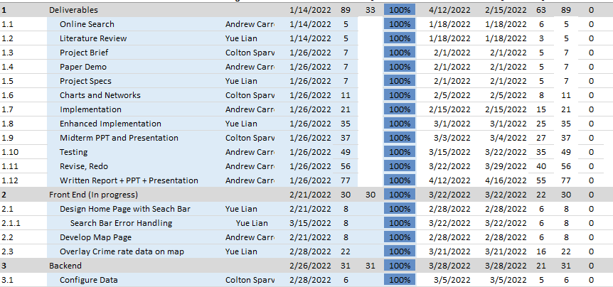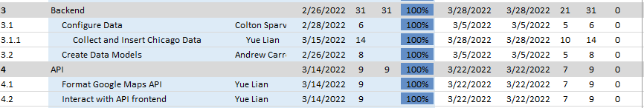

Figure 2.1 - Gannt Chart

## Principle Operation

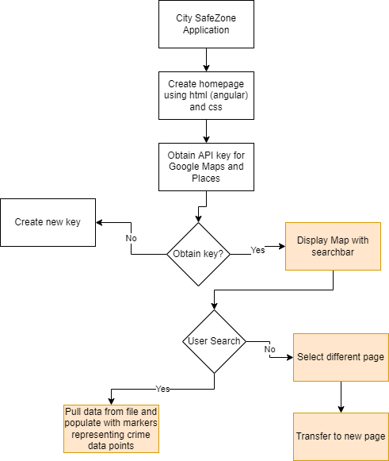

Figure 2.2 - Operational Flow Chart

As soon as the user accesses the application, they have the option of inputting an address to the search bar or selecting the data tab. When the user types in a location in the search bar, the Google Maps API will load with a map view of the specific location entered into the search bar. For example, if the user types “Chicago”, the map will show the entire city of Chicago. After the location has loaded, the map will populate with data markers displaying crime data points. When the user clicks on one of the markers an info box will open up displaying details about the crime. Each info box will display information about the type of crime, date and time, and whether or not an arrest was made. The user can also click on the “x” on the top-right corner of the infobox to close it. The alternative to exploring the main page of the would be to explore the “Data Tab”. The Data Tab shows a dashboard of a city’s crime rate. The Dashboard provides information about recent incidents such as shootings and assaults.

## Design Process

With the number of resources out there, there were multiple routes we could have taken to go design our application. For instance, there are a myriad of libraries and frameworks available to use for our framework. In the beginning, we had many conversations about whether we would use either Angular, React.JS, or Vue for our front-end framework. We chose to use Angular because of its features and we had experience using this framework. Angular is a great component-based interface and beneficial when creating large-scale applications. There were also command-line features that were helpful when getting started.

Working on the API was the most difficult. We knew which functionalities needed to be integrated from an API, but none of us had any prior experience working with APIs. We spent a lot of time researching the process and we finally found one called, “Maps Javascript API.” This API allowed us to customize maps with our own content and imagery. On the Google Maps website, there was code documentation on how to integrate this API using JavaScript lines.

After we figured out the backbone of the design, we worked on planning how to design the website. Our main goal was to create a website that was user-friendly, intuitive, and aesthetically pleasing. User-friendly and intuitive came hand-and-hand. We made sure to place navigation and main functionality in large and visible areas. For instance, the navigation bar is the top part of our website. Typically, websites would have their navigation bar at the top area, so we followed this norm for visibility and intuitive purposes. The search bar is also at the top so it was one of the first things the user will see. To make our website aesthetically pleasing, we chose a color theme. For the search bar, we rounded the corners and implemented a highlighted and hover feature for it so our website did not appear flat.

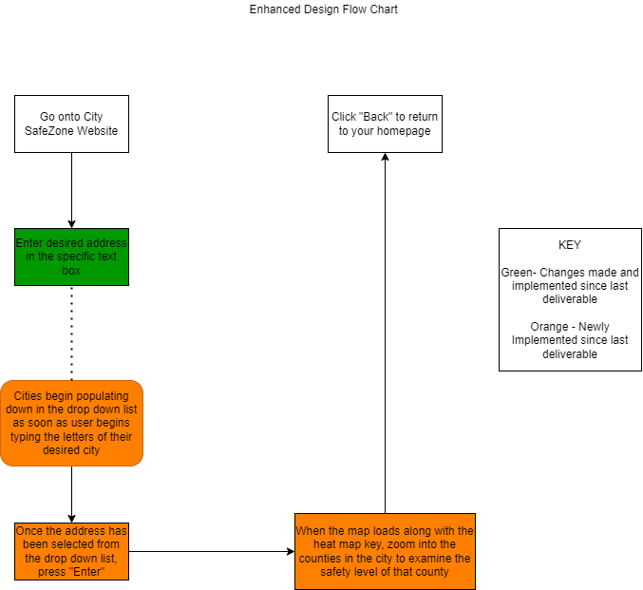

2.3 - Design Flow Chart

## System Design

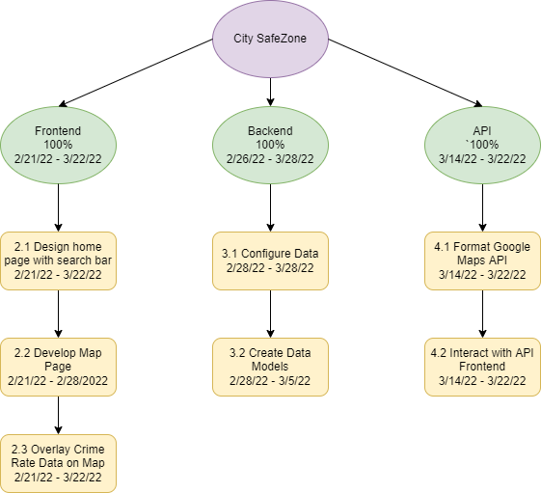

Figure 2.4 - Work Breakdown Structure

### Frontend

We broke down our work into three categories as shown in our Work Breakdown Structure. The three categories are the Frontend, Backend, and API. As previously mentioned, the frontend of our website consists of AngularJS, an open-sourced Javascript tool. In our web page, we included a toolbar and a footer that included data tabs, our logo, the name of our website, and colors to improve the overall look of our webpage. We also centered our map in the middle of the page to make it very obvious for the user. One of the most important features on the Frontend is the search bar. With the inclusion of the search bar, the user can find any destination in the world.

### Backend

Our backend work was pretty simple. We found an .csv file with Chicago Crime Data and copied it into our map. We created a function and used commands to add markers to a location based on the latitude and longitude. Each marker also contains information about the crimes such as whether the type of crime was assault, theft, or arson. We made the info box by creating a variable and adding functions to open and close the boxes.

### API

The last category of the WBS is the API. To authenticate the Google Maps API, we were provided with an API key. We obtained an API key by creating a Google Cloud Platform account. The API key was inserted into a script to access the map. Google’s website provides help with coding to set up the map itself. Using Google’s resources, we were able to create a map function and provide a search box the auto populates when the user types in addresses.

## Testing

### Logical Testing

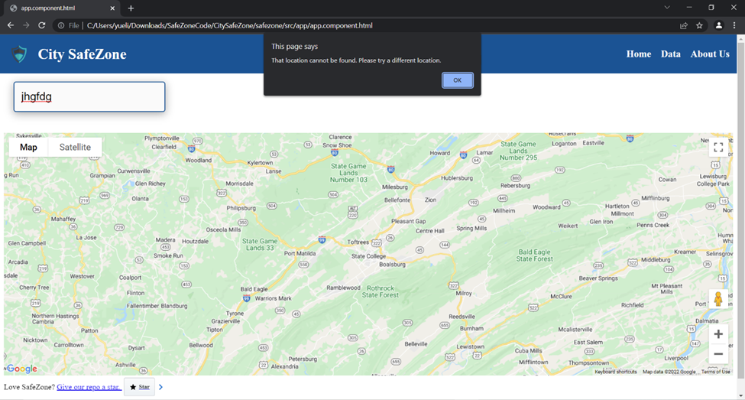

Figure 2.5 - Logical Testing

This case is considered when a user attempts to search for a location that is not found within the Google Maps Library. Originally, Google Maps API already has set stable parameters to ensure users can find their location. Users can type in a zip code, address, and even building name and this API would drop down with options for the users. They even minimize the interference of user error from misspellings. The drop-down list will provide options that are similarly spelled actual locations if the user misspells their locations. However, in the case where the user completely searches for a location that cannot be found, the site would crash because it is attempting to run an unknown request. To resolve this issue, an alert message would pop up to notify the user their location cannot be found and for them to try a different location. Figure 1 below displays the output. The user would fix the problem by clearing the previous search and typing a new location.

### API Testing

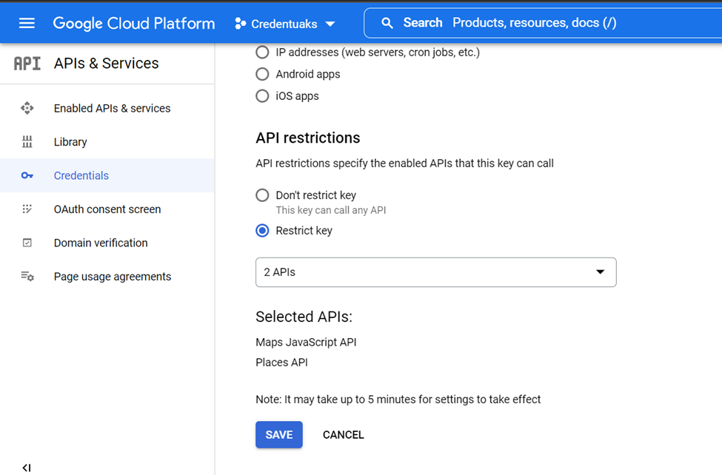

Figure 2.6 - API Testing

It is important to secure an API key to secure the Google Maps Platform account. Restrictions can be changed so that the key can only be used to make calls from certain applications. For example, an API key holder can restrict the API keys so that it can only make calls from iOS applications. Holders can also restrict the API keys to call certain APIs. An example would be if the user decided to restrict a Google API key to only call the Google Maps Javascript API. On the Google Cloud Platform, we restricted our API key so that only the Places and Maps Javascript API can be used. This will prevent unauthorized key usage on other APIs.

### Cross Browser Compatibility

### 

Figure 2.7 - Cross-Browser Compatibility

We considered cross browser compatibility as there are multiple different browsers that users will run City SafeZone on. As the Google maps API is central to our program, its compatibility on competition browsers services like internet edge for example, could cause a lot of issues when trying to access the site on different browsers. Cross browser compatibility testing is essentially the practice of running the website on multiple different browsers to see if it functions properly. While there are programs that can be used to do this testing automatically, they were outside of the group's budget in terms of cost. Therefore, the app was texted manually on multiple Different Browsers. City SafeZone was tested on Google Chrome, Safari, Mozilla and Vivaldi. The app functioned normally on Google Chrome and Safari however on Mozilla and Vivaldi (which are built off chrome) the app would not load and produced an error message.

# **CONCLUSION**

## Changes in development

Our website went through many changes over its short lifespan. Originally, our plan was to display a heatmap of data points to inform people about which areas within a city are safe to travel to. The implementation of a heatmap caused several problems in our application. First of all, after implementing the heatmap, sometimes the API would not work anymore and show up as an entire blank map. The heatmap data most likely interfered with the other code in our map preventing it from working. Instead of using the heatmap, we added basic markers to the map. The markers became an upgrade over the heatmap because when the user clicks on the markers, they can see information about the crime. Users can figure out more about the type of crimes in the area when they click on the markers.

Another change in our development was that we were originally prepared to create a search bar that displayed only the biggest cities in the U.S. Before our changes, the user was supposed to click a search bar and a dropdown of major cities would show up. Now when the user clicks on the search bar, they can type in any address in the world.

## Challenges

One challenge we had to overcome was figuring out how to display our data properly. Our original plan was to show users a heatmap of major cities in the U.S. so that they can determine the safety of the area they plan on traveling to. However, the heatmap was difficult to implement so we scrapped the idea. At one point, when the heatmap was working, we noticed that the size of the heatmap data points took up a large amount of area. Even with a working heatmap, adding a plethora of points would cause the entire city to show up as a huge red circle. From the user’s perspective, they would search up an area of a city and see only red. Our intentions were not to discourage the user from traveling to a certain area in a city because they see that the whole city shows up as red. Instead, we wanted to show only particular areas that experienced high volumes of crime. To solve the problem, we would have had to weigh the colors of the heatmap differently depending on every type of crime that exists in databases. The next move for us was figuring out how we were going to display the data. We decided to create basic markers to display points where incidents occurred.

A major challenge during this project was our knowledge of the programming language. Coming in, all three of us had a high-level understanding of web development. We each were not comfortable nor anticipating being the “coder” of the group. However, we realized the challenge early on and worked really well together to figure out how to code our application. The web design was not as challenging, however, the functionality was. We had to do a lot of research on function implementation.

Also, we did not find a repository that was similar to what we wanted. Due to this, we had to code everything from the start. As mentioned, the web designing was not challenging, but when it got to implementing the app’s functions, we hit a road blockage there. None of us have also worked with APIs before so it was challenging trying to start that step. We knew we needed a map API, but we had no experience finding or implementing an API. We went through different routes during the trial-and-error phase to get an API.

Lastly, we did not have the funding for this project. If we did have money, then we would be able to implement more expansive and functional APIs. When we first searched for a map API, we wanted to implement one from the ArcGIS website. We could have more access to testing and implementation features.

## Lesson Learned

Throughout the course of this project, the group has learned a lot. Before any part of the project was coded, we had to learn how to work as a group on this project, learning to work in an agile environment. Planning work, meetings, and other project-related matters taught the team a lot about project management. Implementing communication and management skills learned in previous IST classes. This project helped us hone skills that will be vital to us in our professional careers, with real-world projects similarly needing to be updated and changed on a dime as circumstances arise.

The group also learned a great deal of technical knowledge in the realm of coding. Before the beginning of the project, multiple team members had little to no experience with the programs that were used to make our application. The group learned how to navigate and pull resources from GitHub, as well as learning how to use GitHub in tangent with VScode. Completing the project also meant learning multiple coding languages that we had little experience with.

# **FUTURE WORK**

Due to our timeline, any new modifications will be left for the future. Our main goal this semester was to create an application that targeted a problem in our current social climate. Our application demonstrates the front end and the base level of its features. With more time and resources, this application has great possibilities for improved design and functionality.

## Heatmap

We had to overcome a challenge with figuring out how to display our data properly. Our original plan was to show users a heatmap of major cities in the U.S. so that they can determine the safety of the area they plan on traveling to. However, the heatmap was difficult to implement so we scrapped the idea. At one point, when the heatmap was working, we noticed that the size of the heatmap data points took up a large amount of area. Even with a working heatmap, adding a plethora of points would cause the entire city to show up as a huge red circle. From the user’s perspective, they would search up an area of a city and see only red. Our intentions were not to discourage the user from traveling to a certain area in a city because they see that the whole city shows up as red. Instead, we wanted to show only particular areas that experienced high volumes of crime. To solve the problem, we would have had to weigh the colors of the heatmap differently depending on every type of crime that exists in databases. We still think the heatmap would still be effective if we came up with a way to implement it into our map. We thought a good idea for the website would be to add a tab that allows the user to switch between a heatmap and markers. Given more time, we could potentially implement the feature into our website.

## Backend Data

In the future, to better improve the app, we could change our data strategy. In its current state, data for our application comes from a yearly crime database. To improve the user experience, and make the map more legible and updated, it would be best to use monthly crime statistics. In conjunction with this, we could add a built-in mechanism to update crime data in real-time as they’re reported. The former improvement, using monthly crime data, would help provide users with a timelier and more updated map, seeing as crime patterns can change year to year or month to month. Communities and precincts can improve over time and using monthly data would better help reflect that. The second improvement, updating data in real-time, would not only provide users with the most up-to-date information but would make the team's job in maintaining the application way easier. As it is now, team members have to input crime data into the application manually. Adding a mechanism to automatically add data from a database would allow the application's data to be updated in real-time without any additional effort from the team.

## Mobile App Development

Currently, this is only a web application. After we finished implementing all the functions, we would move this application to a mobile application. Since this is an application that can be used for a quick search, we would like this to be easily accessible. For some instance, a user can have the thought of wanting to search the crime rate of a city, but at the moment only has their phone on hand. It would be ideal for our application to be mobile. We would work on making its iOS and Android.

## References

“Safety and Crime Prevention Tips | Baltimore Police Department.” www.baltimorepolice.org, www.baltimorepolice.org/safetytips. Accessed 14 Apr. 2022.

Hutchinson, B. (2021, December 8). *'It's just crazy': 12 major cities hit all-time homicide records*. ABC News. Retrieved January 27, 2022, from https://abcnews.go.com/US/12-major-us-cities-top-annual-homicide-records/story?id=81466453

U.S. Department of Housing and Urban Development. (2016). *Neighborhoods and violent crime: HUD USER*. Neighborhoods and Violent Crime | HUD USER. Retrieved January 25, 2022, from https://www.huduser.gov/portal/periodicals/em/summer16/highlight2.html#:~:text=But%20although%20overall%20violent%20crime%20rates%20have%20declined,the%20most%20violent%20generally%20remained%20the%20most%20violent.

Drexel University Urban Health Collaborative. (2019, October). Community Health Profile: Kensington, Philadelphia. Philadelphia. <https://drexel.edu/~/media/Files/uhc/briefs/Kensington_brief.ashx?la=en#:~:text=Philadelphia%20is%20the%20poorest%20of,one%20of%20the%20poorest%20cities.&text=In%20Kensington%2C%20the%20violent%20crime,violent%20crimes%20per%2010%2C000%20people>

*SaferWatch - Apps on Google Play*. (n.d.). Play.google.com. Retrieved January 27, 2022, from https://play.google.com/store/apps/details?id=com.ad.saferwatch&hl=en_US&gl=US